Singapore Art Festival

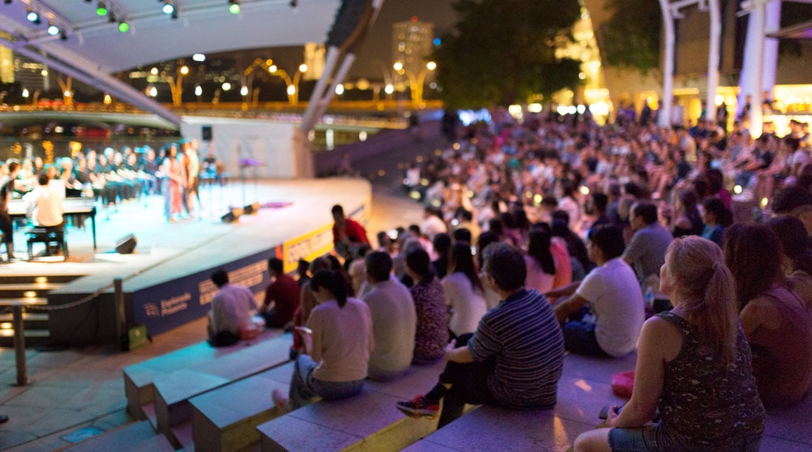

As Singapore’s annual pinnacle arts festival, the Singapore International Festival of Arts (SIFA) presents captivating and diverse works across theatre, music, dance, film and visual arts. First launched as the Singapore Festival of Arts in 1977, the festival has gone through several evolutions and inspired generations of arts lovers and practitioners.

Today, the highly-anticipated festival is a high-point on Singapore’s arts and cultural calendar.

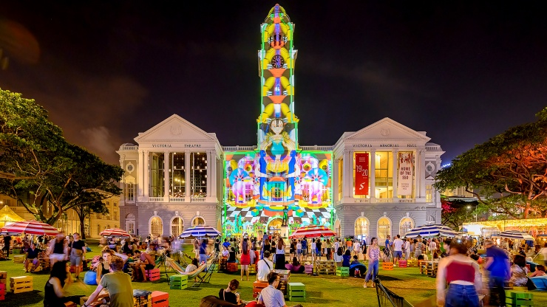

Under the helm of Festival Director Gaurav Kripalani from 2018–2020, SIFA continues its festival mission to champion the creation and presentation of Singaporean and international works. At SIFA 2019, The Arts House will once again be transformed into the Festival House.

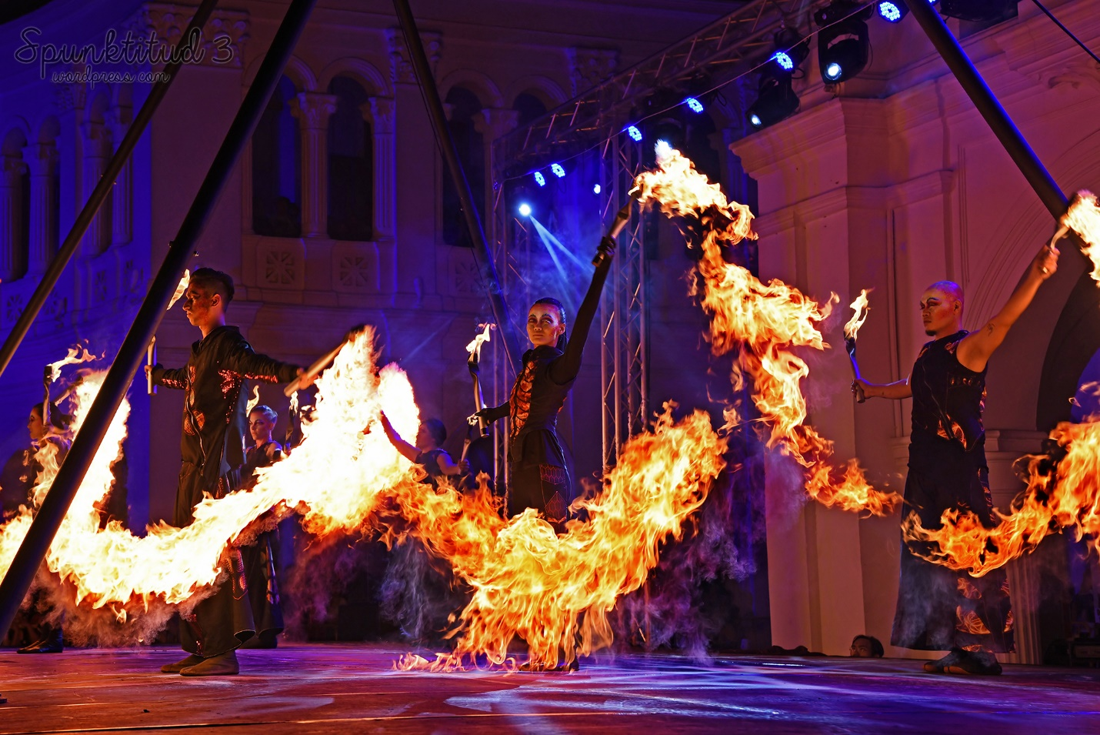

The festival brings together local and international authors, emerging writers and publishers in a range of events that can be enjoyed by audiences of all ages.

Expect panel discussions, writing workshops, live readings by authors, dinners with writers, publishing symposiums, participatory events, special guest lectures and film screenings.

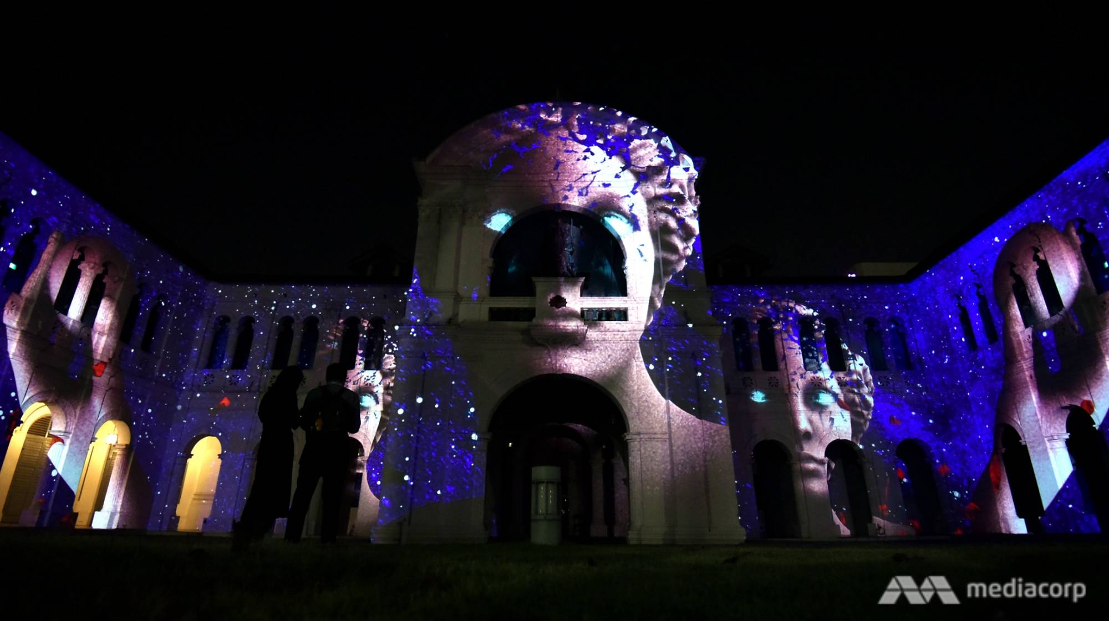

For book lovers, the Singapore Writers’ Festival is Singapore’s major literary event of the year. With a long history dating back to 1986, it is one of the few multi-lingual literary festivals in the world, celebrating literary works in Singapore's 4 official languages – English, Mandarin, Malay and Tamil.

**Don’t miss:**Street performances  
**When:**15th – 31st May 2020